Help Guide for Visitor Registration Application

How to register a new meeting:

Fill in all the fields required (All are needed before you can sign in, name etc)

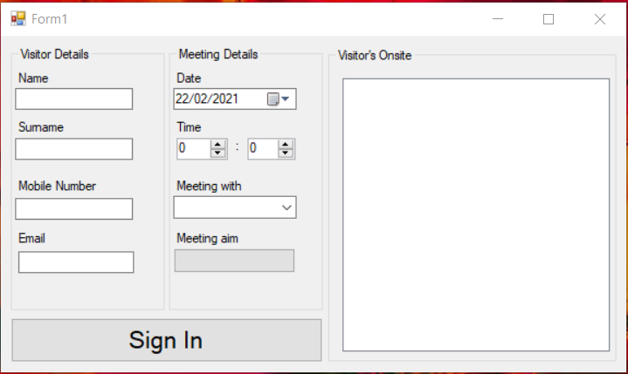

Then click Sign In All the information will then be stored in the “Visitors Onsite Section.

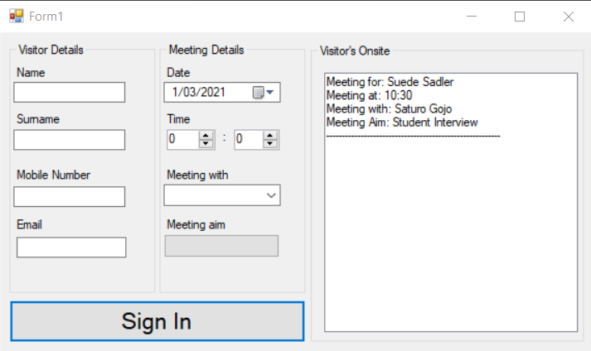

Validation on all Fields:

Enter the First name of visitor in text box.

Enter the Surname of visitor in text box.

Enter Mobile number of visitors in number box,

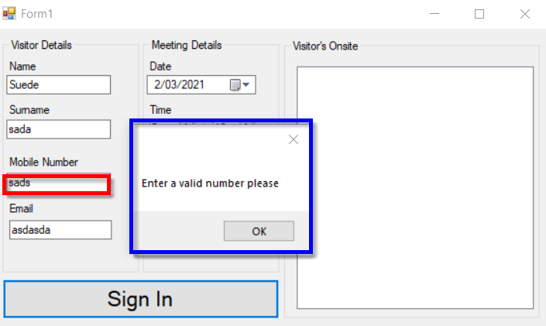

You will only be able to enter numbers in this box otherwise you will not be able to sign in.

Enter a valid email, other wise you will get an error and no be able to sign in.

Enter the date properly.

Enter and hour and minute or your meeting time.

How to Select who you are meeting with:

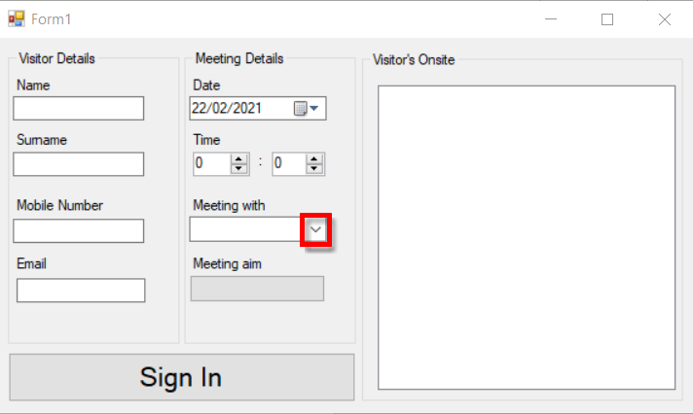Click on the arrow highlighted in red box.

Then select who you are meeting with from the list.

How to Select a Meeting Aim:

Click on meeting aim in red box then another form will show and select the purpose of your visit today from the options displayed in the second red box.

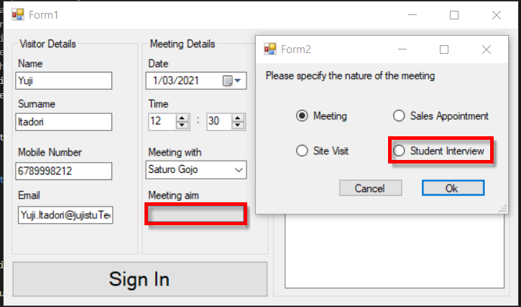

After all of these things are done you can then Sign In.